Applying a template
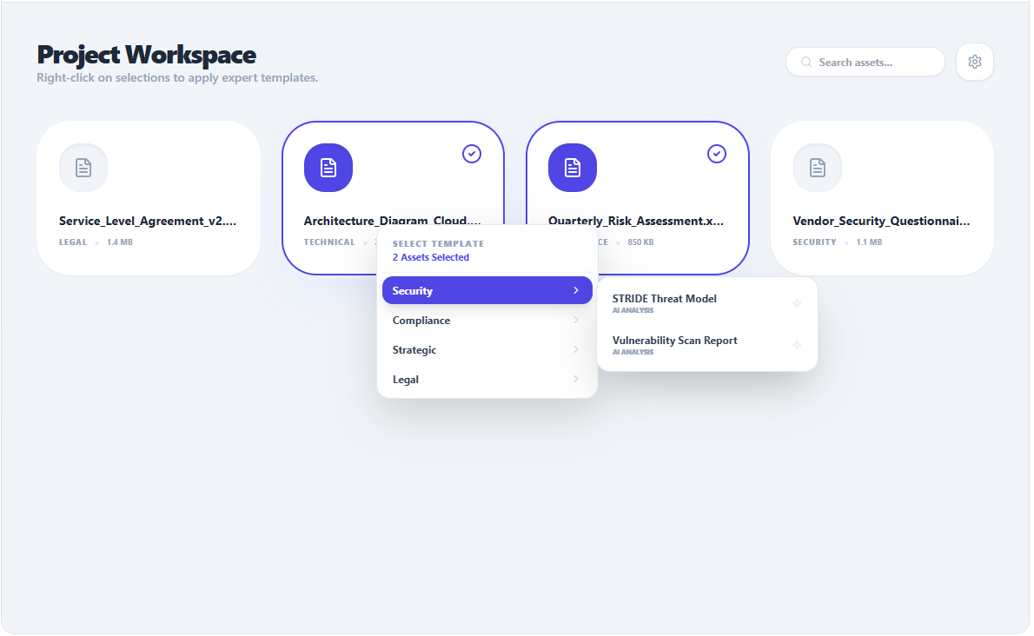
Figure 1: The user Right-Clicks on an asset (or a selection of Assets) in the canvas. A contextual menu displays the list of available templates, organized per category
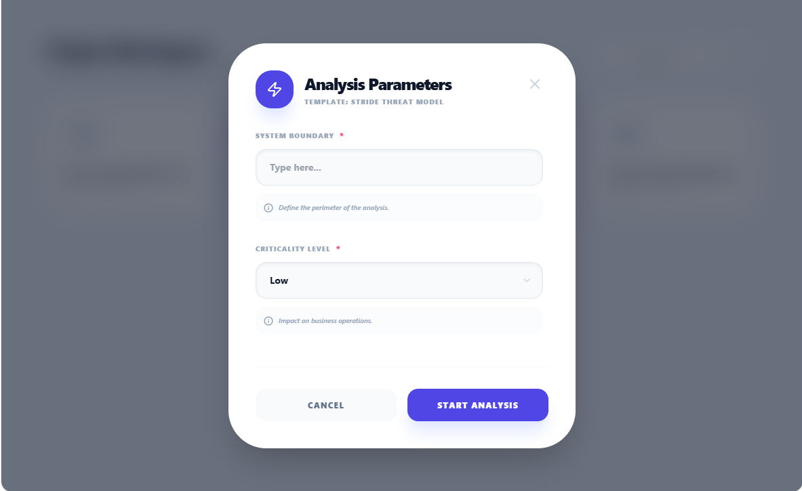
Figure 2: Based on the definition of the template, the user may have to enter some values (for a defined variable) or to select in a list (for list-type variables)
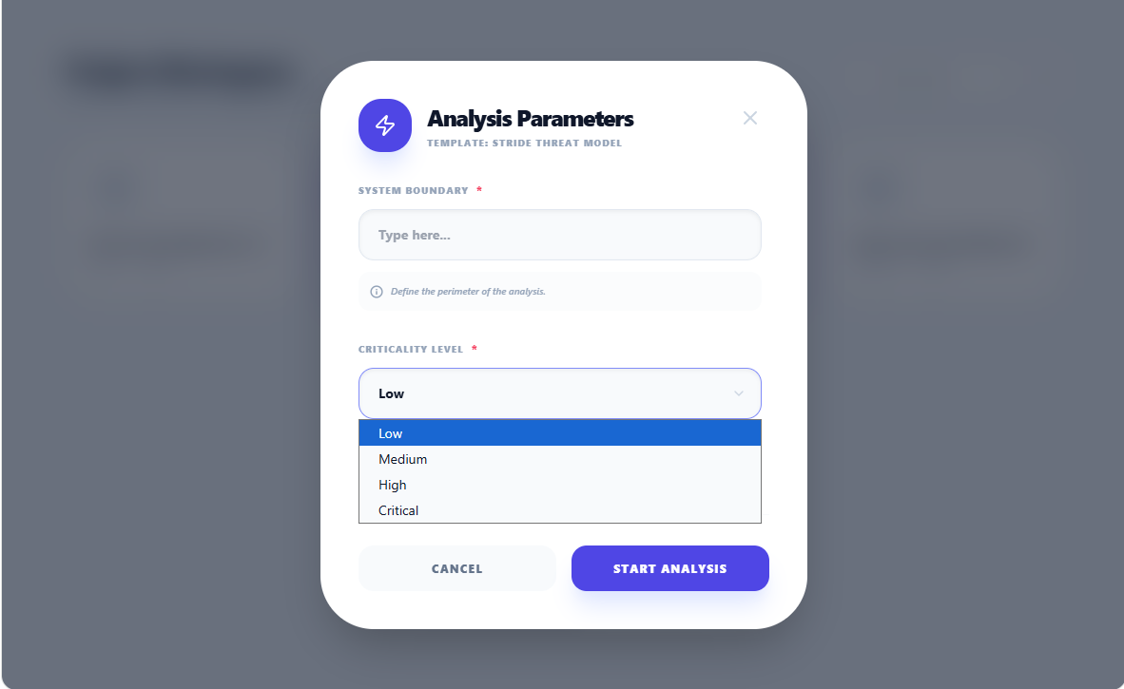
Figure 3: Example of a list
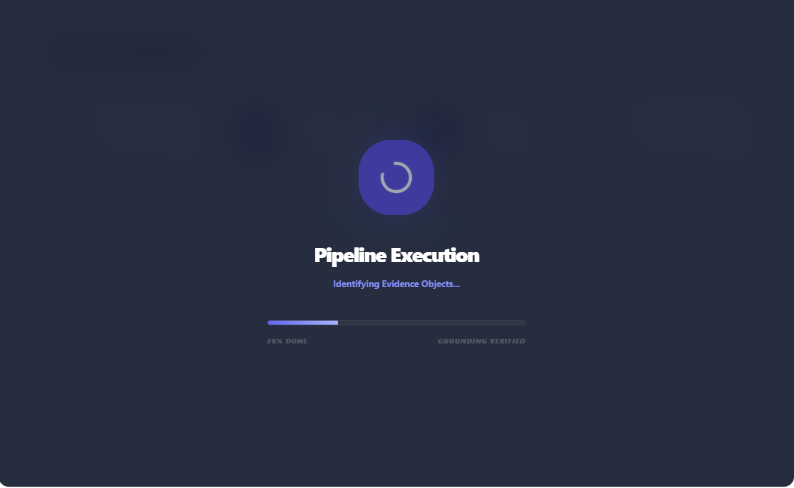
Figure 4: When Starting the execution, the template's pipeline is executed

Figure 5: Ultimately the report is displayed including (on the left side) the report itself that can include text or:and diagrams... And on the left panel, the evideces that support the analysis

Figure 6: The user can click on an evidence ti jump to the source. There is also the reasoning logic.

